MACH4METAL

metalworking machinery
Transito 21
6909 DA BABBERICH Netherlands
Tel. +31 (0)316-247123
Fax: +31 (0)316-247956
info@mach4metal.com
www.mach4metal.com

Bank No : 66.52.13.883
IBAN : NL33 INGB 0665 2138 83
BIC : INGBNL2A

ZOPF Profile bender ZB 80 / 3
- Make : ZOPF Germany
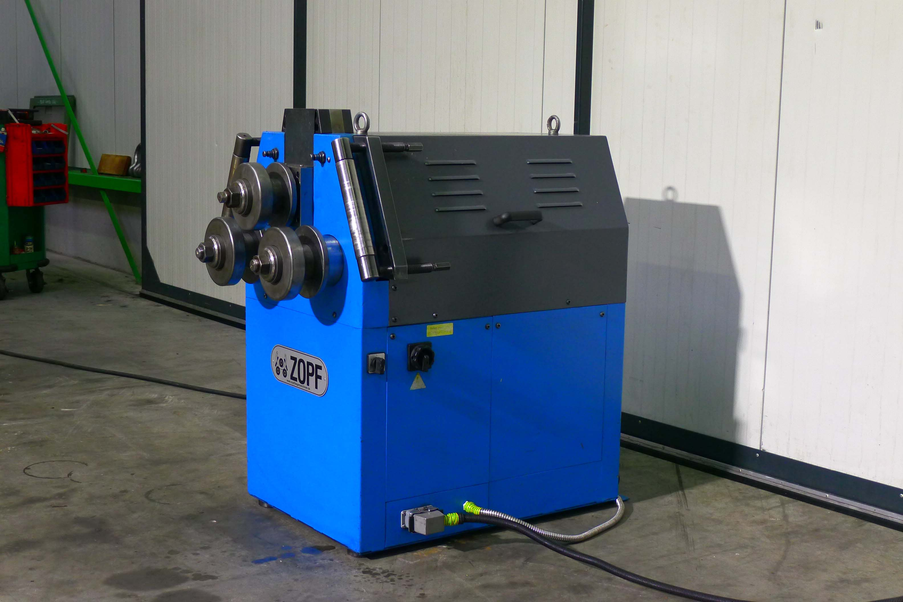
- Typ : ZB 80 / 3 HZ ECO
- Serial No. : 9810163
- Age : 2009

- Ø Top roll shaft : 80
- Ø Side roll shaft : 80

- Ø Top roll : 168
- Ø Upper roll : 178
- Shaft rpm : 8.5
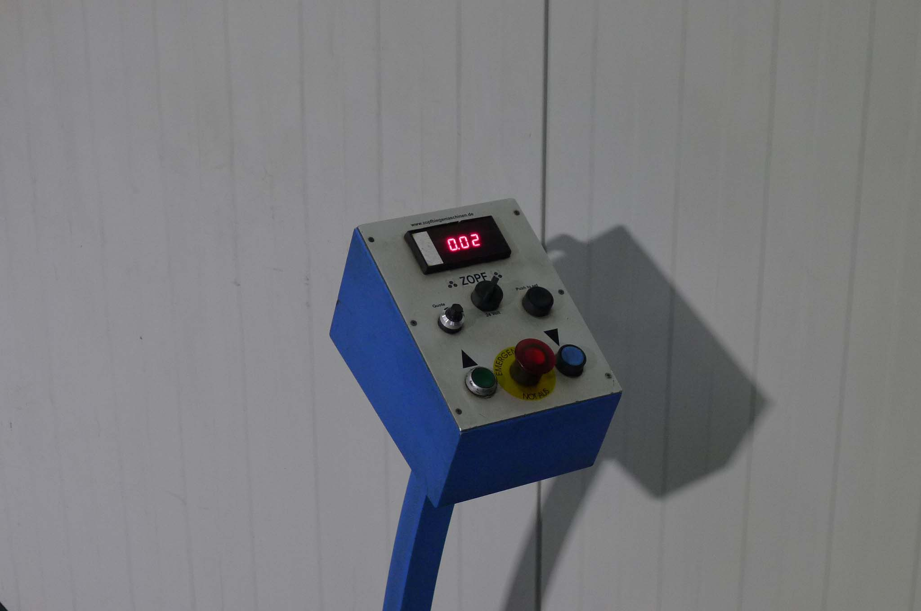

- Power : 2 kW
- Force cylinder : 12 ton

- 3 rolls are driven
- Top roll hydraulic adjustable
- Horizontal & vertical use
- Hardened shaft

- Angle 60 x 60 x 6 Ø 800
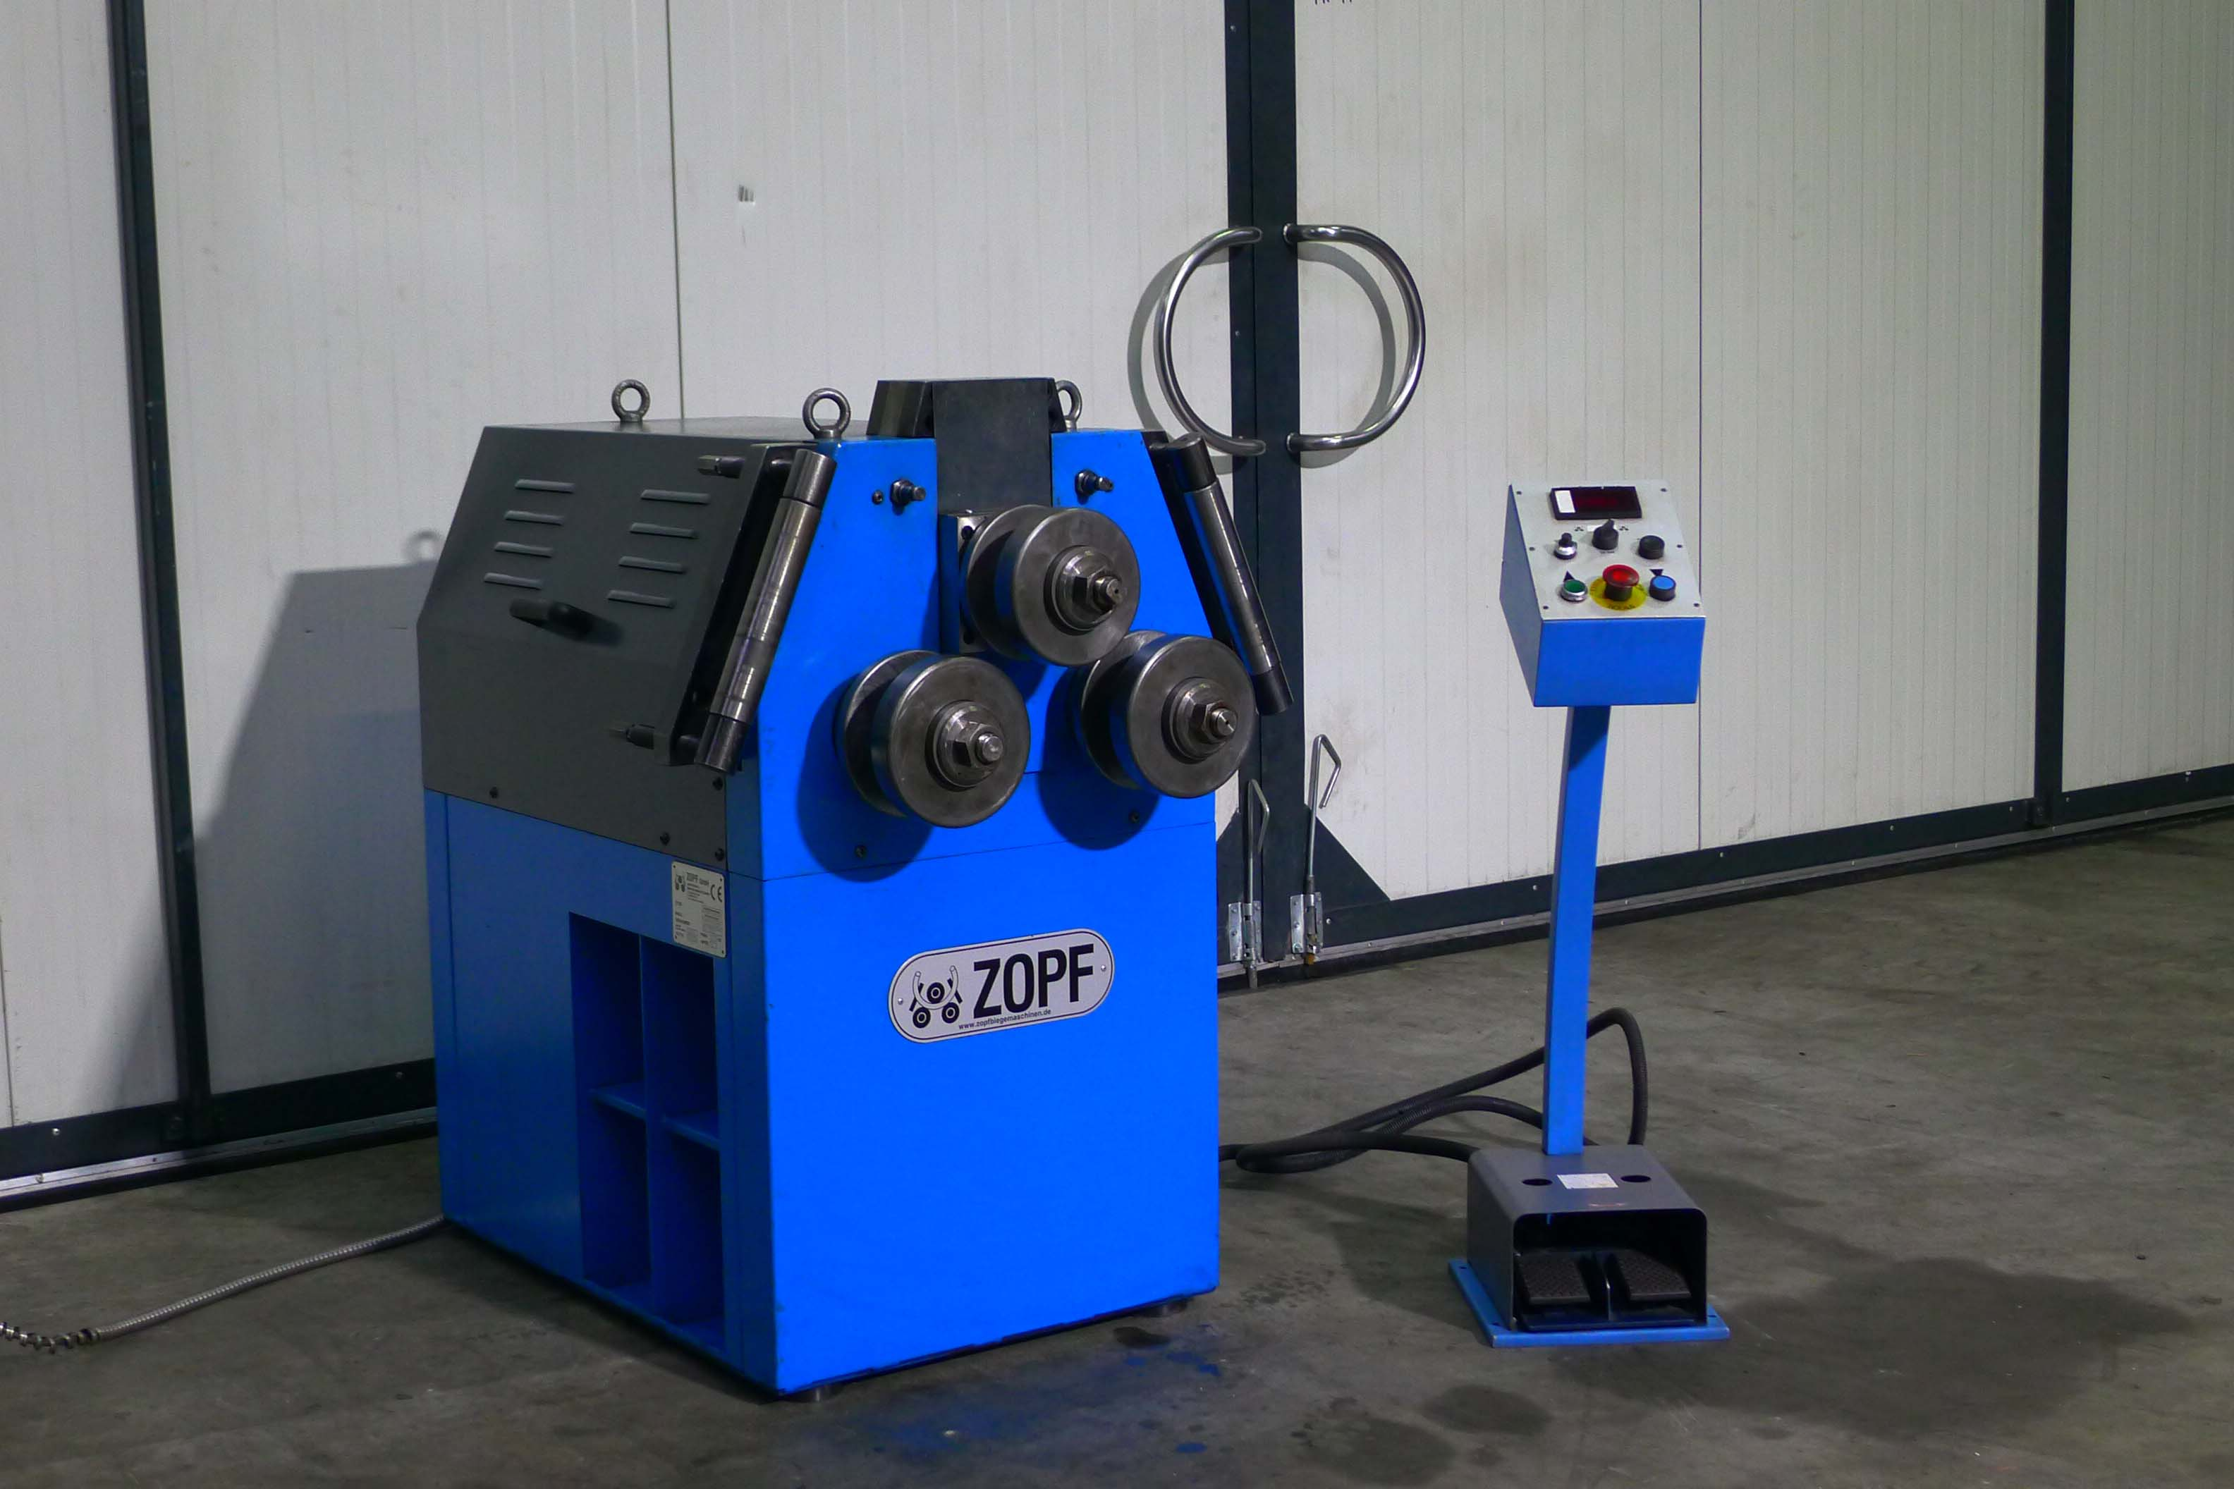
- Flatt 60 x 15 Ø 600
- Tube 80 x 2 Ø 1650

- Dimensions
- Length : 900
- Width : 650
- Height : 1.070
- Weight : 500

- Digital read out with memory
- Slide bars are exchangeable
- Shafts are supported by conical bearings

Please Note: The above information has been obtained to the best of our ability and belief from, and from the manufacturers where possible. It is given in good faith, but its accuracy can not be guaranteed. Accordingly, it will not form a representation or constitute contractual terms. We advise you to check any vital details!

